HORSE POWER PAARDENKRACHT MERRY CRISTMAS
And Happy 2012
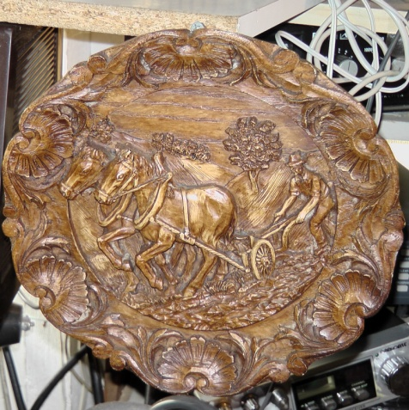Pa 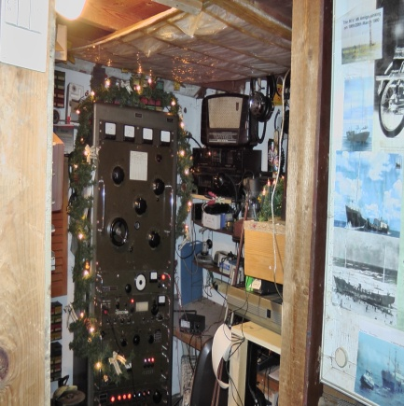

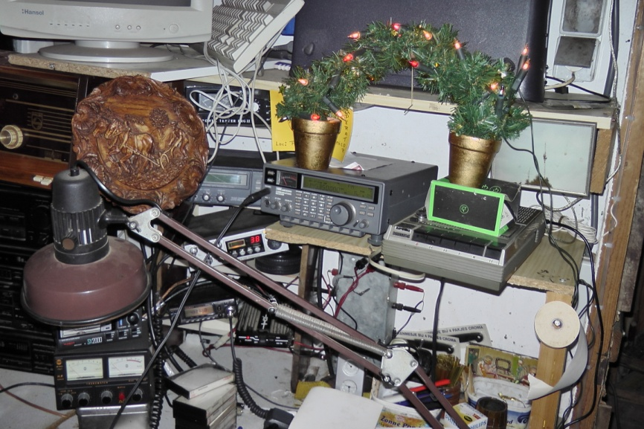

From
NETHERLANDS

